*“ Curious, motivated and determined ”*

Currently, a third year student majored in physical sciences. Science has been an integral part of my life since I was a teenager. My curiosity and my analytical mind allow me to move quickly in this area. My studies offer me many opportunities. By becoming a physicist, I want to do research that will find their usefulness especially in the technological world.

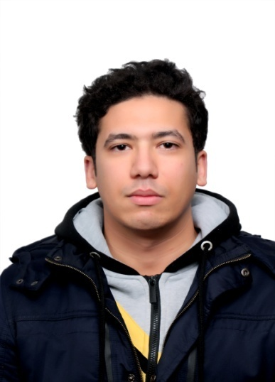

**Aymen MAHMOUDI**

Date of birth: 01/02/1997

**Address**: 41 , Hedi Chaker street , Ennajeh city, , Bizerte

**Telephone:** +216 41 785 915

**E-mail:** mahmoudi7050@gmail.com

**Skype ID :** mahmoudi7050

**Github username :** m7050

**Education**

Ibn Rochd and Ibn Sina secondary School 2016

**Baccalaureat diploma**

**Bachelor's degree in Fundamental Physics**

1st grade : general and inorganic chemistry , point mechanics, geo optics, electrostatic-magnetic mathematics , experimental physics

(16.53/20 distinction : very good )

2nd grade : electromagnetism, mechanics of solids, physical optics, electronics, thermodynamics, hyperfrequency, mathematics, wave physics, restricted relativity, experimental physics

(14.93/20 distinction : good )

3rd grade**:** quantum mechanics, physical optics, analytical mechanics, particle physics, ph-statistic and semiconductor, mathematics, experimental physics

(14.93/20 distinction : good )

Branche : mathematics

physics and general mathematics, english, french and german

(15.72/20 distinction : good )

Faculty of Sciences of Tunis 2016 – today

**National competition for basic education**

Ibn Charaf preparatory school 2012

Basic notions on the scientific, literary and human field

English French

(14.30/20 distinction : good )

I have been honored on two occasions by the Association Development Without Bordersat Menzel Bourguiba - Tinja ADSF(9th grade and baccalaureate ) and also three times by the Tunisian Association of Physics STP (grade 1 , grade 2 and grade 3) as one of laureate at the national level.

I was the laureat of my promotion during the 3 years of the licence and in 2017 I was the laureat of the faculty.



**Arabic:** Mother Tongue

**French:**

TCF_TP (French Fluency Test) at the French Institute in Tunis in 2018 / Level C1

The degree in French (B2 level) of the Betalife center.

**English :**

English training at *Mega Formation* 2016

2 trainings in English at *Betalife center* in Menzel bourguiba 2017 and 2018

English training at *RG Formation* in Tunis 2018

 a degree in English (B2 level) from *Betalife center*.

a degree in English from the training center: *Spectrum Training Center*

**German:**

Basic training in German for two years

18/20 in baccalaureate exam

**Ms Office:**

Extensive knowledge in LibreOffice and MS Office (Word, Excel, Powerpoint).

**Programming:**

Advanced training in Pascal (16.62 / 20 baccalaureate exam), GeoGebra and Matlab.

Basic training in Python.

**Multimedia:**

Extensive training in FastStone, Movie Maker, Audacity and Paint.

Basic training in Photoshop and Premiere.

**Astronomy Software:**

Advanced training in Stellarium.

Basic training in AutoStakkert, DeepSkyStacker and RegisTax (Astrophotography)

**Languages and computers**

**Extracurricular Activities**



I am an active member in Tunisian Association of Physics STP, Tunisian Association of Science and Nuclear Consciousness ATSCN, Astronomical Association of Tunisia_SAT, OSIRIS and many other scientific Clubs which give me the opportunity to discover the reseaarch field and attend many conferences

* Hackathon (Hack for Democracy H4D) in 2017.
* International Symposium on Astronomy organized by the Tunisian Association of Astronomy (SAT) in Djerba in 2018.
* Participation with the SAT in organizing the “Nuit des Etoiles”, which welcomed more than a thousand visitors to observe the eclipse of July 2018.
* 5th African Regional Congress of the International Radiation Protection Association (AFRIRPA 5) in Tunis in 2018.
* Various trainings on project creation and entrepreneurship and I several social and scientific conferences:
* The conference of Mario Campanelli (Italian physicist working on the ATLAS project at CERN) at the FST in 2016.
* The conference of mathemathcien Cédric vilani at the FST in 2016.
* FST Quality Day in November 2016.
* The conference of Tunisian mathematician and historian Mahdi Abdeljaouad on the history of Arabic mathematics at the Cité des Sciences in 2017.
* The conference Mr Nejm Eddine Jidane on the formation of the stars and  their life cycle at the Cité des Sciences in 2018.
* The conference of Mr Adel Trabelsi (Professor at the FST and at the Ecole Norm Sup and physicist at CERN) on dark matter in the event of the Dark Matter Days organized by the Cité des Sciences in October 2018.
* Mr. Hichem Ben Yahia's lecture on solar activities and the measurement of solar flares and several other conferences and debates on space science in general.
* Participated in the name of the association Citizens Actors to the consultation around the revision of the legal framework of associations in May 2018.
* Conference debate "Food Additives and Health" presented by Pr. Nabiha BOUGUERRA BOUZOUITA, Director of the School of Food Industries of Tunis (ESIAT) at the Cité des Sciences in 2019.
* The conference of Mr Riadh Nessib on Python in 2019 at the Cité des Sciences in 2019.
* Debate on the problems of youth at the youth center organized by the Maghreb Institute for Sustainable Development under the direction of Mr Adnen Hasnaoui.
* Several volunteer work (Embellishment of the children's service at the hospital of Menzel Bourguiba, cleaning campaigns ...).
* First Aid training offered by the Red Crescent.



* Program of the Dynamisation of cultural life university organized by the Ministry of Higher Education and the German foundation Konrad Adenauer Stiftung (Kas) in Hammamet in 2018.
* Advanced Training Course in Astronomy and Astronomical Observation Techniques at the City of Science in Tunis in 2019.
* The 2019 STP Spring School Computational physics
* The 2018 STP Winter School on Magnetism.
* Training in the hhhhhhh laboratory LSAMA

**Training**



Reading (Scientific news , Theology and Personal Development )

  Astronomy

  Dance Michael-Jackson (I already animated Galas and trained some young people who performed very well)

  Gaming and High-Tech

**Hobbies and interests**